SET 6: PRODUCT SALES ANALYSIS
Ayesha Siddiqa S
192324305
1. Grouped Bar Chart – First Quarter Sales
Aim
To create a grouped bar chart to compare sales of each product during January, February, and March.
Algorithm
1. Create product and monthly sales data.
2. Store monthly sales in a matrix.
3. Use barplot() with beside = TRUE.
4. Add labels and a legend.
Code
product <- c("Product A", "Product B", "Product C")
sales <- matrix(c(2000, 2200, 2400,
1500, 1800, 1600,
1200, 1400, 1100),
nrow = 3, byrow = TRUE)
colnames(sales) <- c("January", "February", "March")
rownames(sales) <- product
barplot(t(sales),
beside = TRUE,
col = c("skyblue", "orange", "lightgreen"),
xlab = "Product",
ylab = "Sales",
main = "First Quarter Product Sales",
legend.text = colnames(sales))
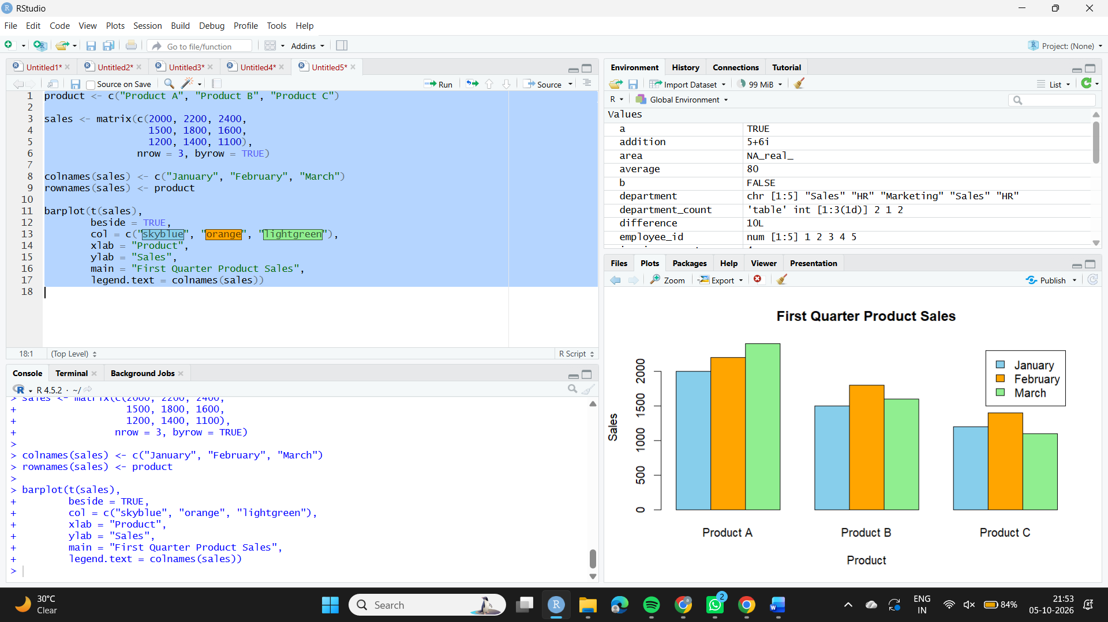
Observation
Product A has the highest sales in all three months. Product C has the lowest sales overall.

2. Stacked Area Chart – Overall Sales Trend
Aim
To create a stacked area chart representing the overall sales trend of all products over three months.
Algorithm
1. Create vectors for months and product sales.
2. Calculate cumulative sales.
3. Use polygon() to create stacked areas.
4. Add labels and a legend.
Code
month <- c("January", "February", "March")
a <- c(2000, 2200, 2400)
b <- c(1500, 1800, 1600)
c <- c(1200, 1400, 1100)
ab <- a + b
abc <- a + b + c
x <- 1:3
plot(x, abc,
type = "n",
xaxt = "n",
xlab = "Month",
ylab = "Sales",
main = "Overall Product Sales Trend")
axis(1, at = x, labels = month)
polygon(c(x, rev(x)),
c(rep(0, 3), rev(a)),
col = "skyblue", border = NA)
polygon(c(x, rev(x)),
c(a, rev(ab)),
col = "orange", border = NA)
polygon(c(x, rev(x)),
c(ab, rev(abc)),
col = "lightgreen", border = NA)
legend("topleft",
legend = c("Product A", "Product B", "Product C"),
fill = c("skyblue", "orange", "lightgreen"))
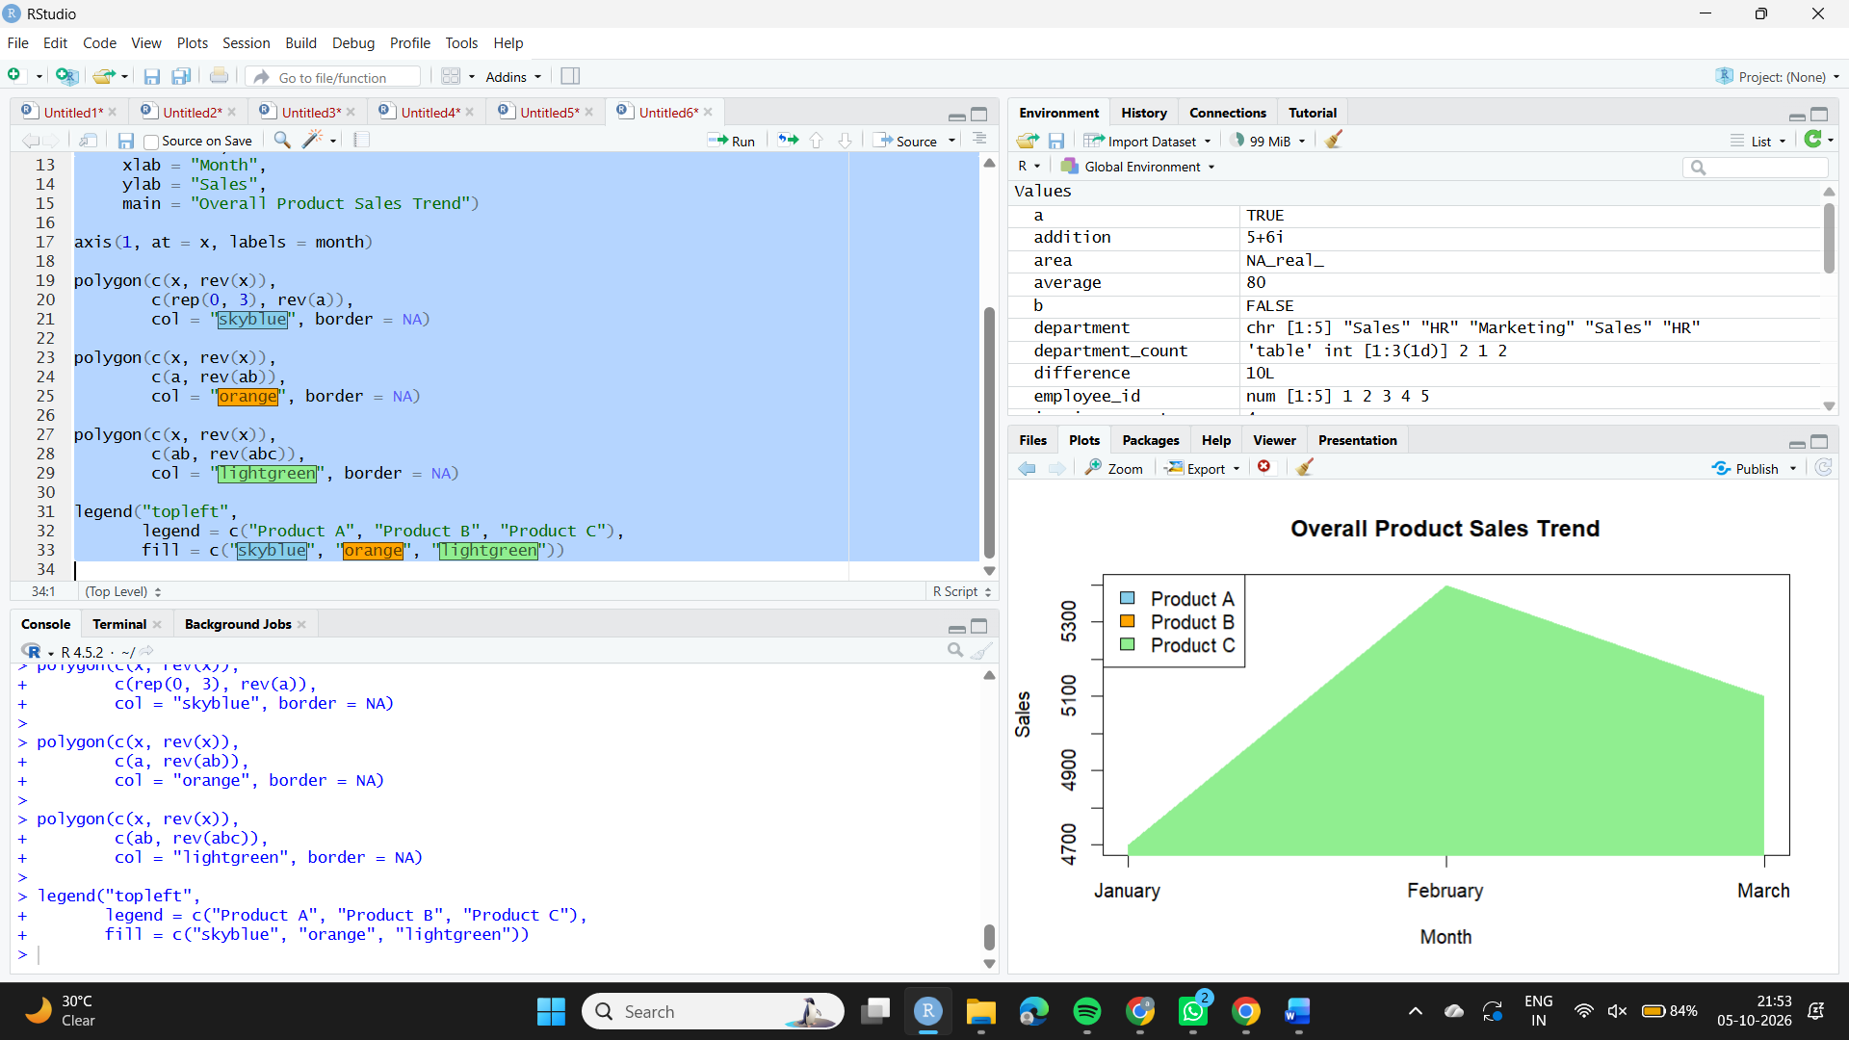
Observation
The stacked area chart displays the combined sales contribution of Products A, B, and C across the three months.

3. Table – Monthly Sales Data
Aim
To create a table showing the monthly sales data for each product.
Algorithm
1. Create vectors for product names and monthly sales.
2. Combine them into a data frame.
3. Display the data frame as a table.
Code
sales_data <- data.frame(
Product = c("Product A", "Product B", "Product C"),
January = c(2000, 1500, 1200),
February = c(2200, 1800, 1400),
March = c(2400, 1600, 1100)
)
print(sales_data)

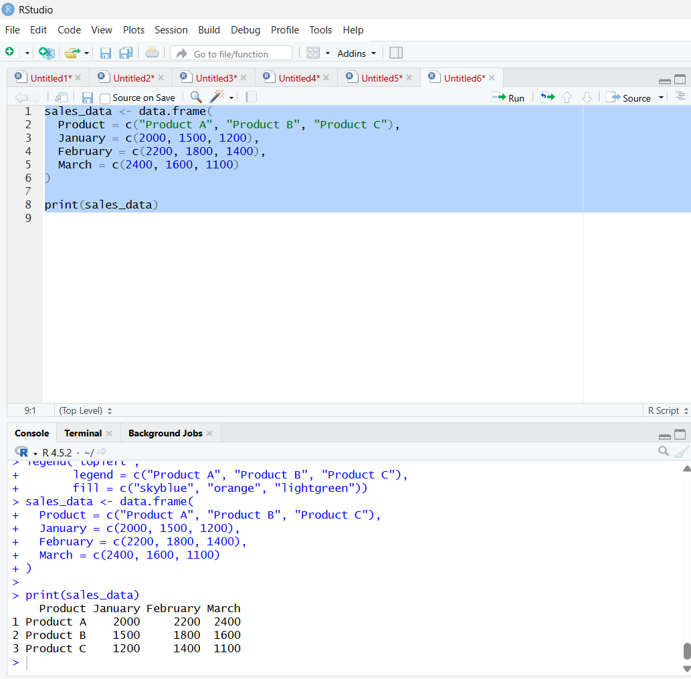
Observation
The table displays the January, February, and March sales for each product clearly.

4. Tableau Dashboard
Aim
To develop an interactive Tableau dashboard combining the grouped bar chart, stacked area chart, and table.
Algorithm
1. Create an Excel or CSV file with the monthly sales data.
2. Connect the file to Tableau.
3. Create the grouped bar chart.
4. Create the stacked area chart.
5. Create the sales table.
6. Create a dashboard and add all three sheets.
7. Add filters for interactive exploration.
Code
Create the three sheets in Tableau and place them on a new Dashboard. Add Product and Month filters as required.
Observation
The dashboard provides an interactive view for comparing product sales by month and examining the detailed sales table.

